**LAPORAN PRAKTIKUM**

Nama : Maftuchati

NIM : 18090015

Kelas : 5B

**PRAKTIKUM 2**

1. Source Code

* latihan1-> application/controller

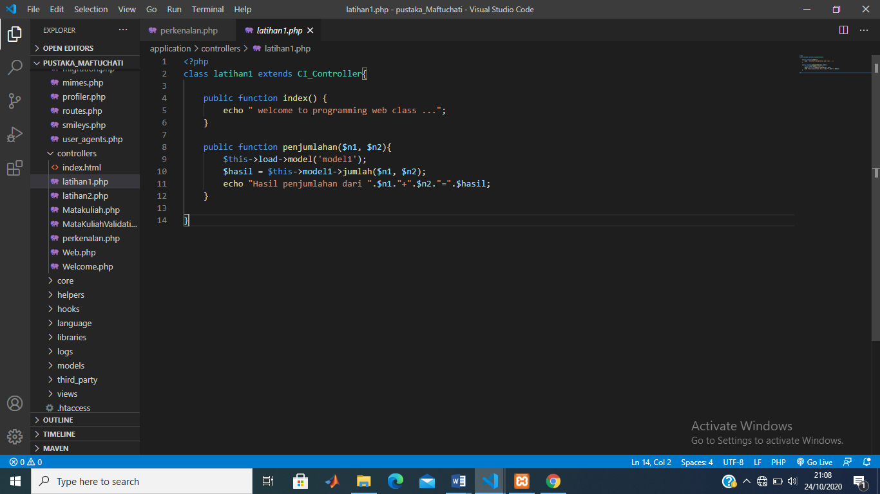

* latihan2 -> application/controller

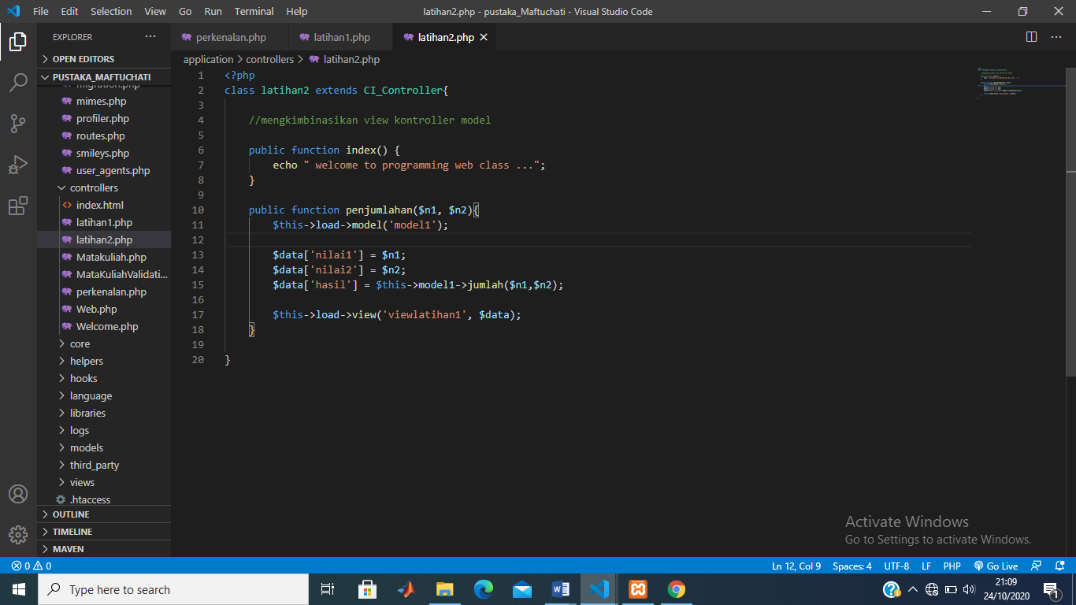

* model1 -> application/model

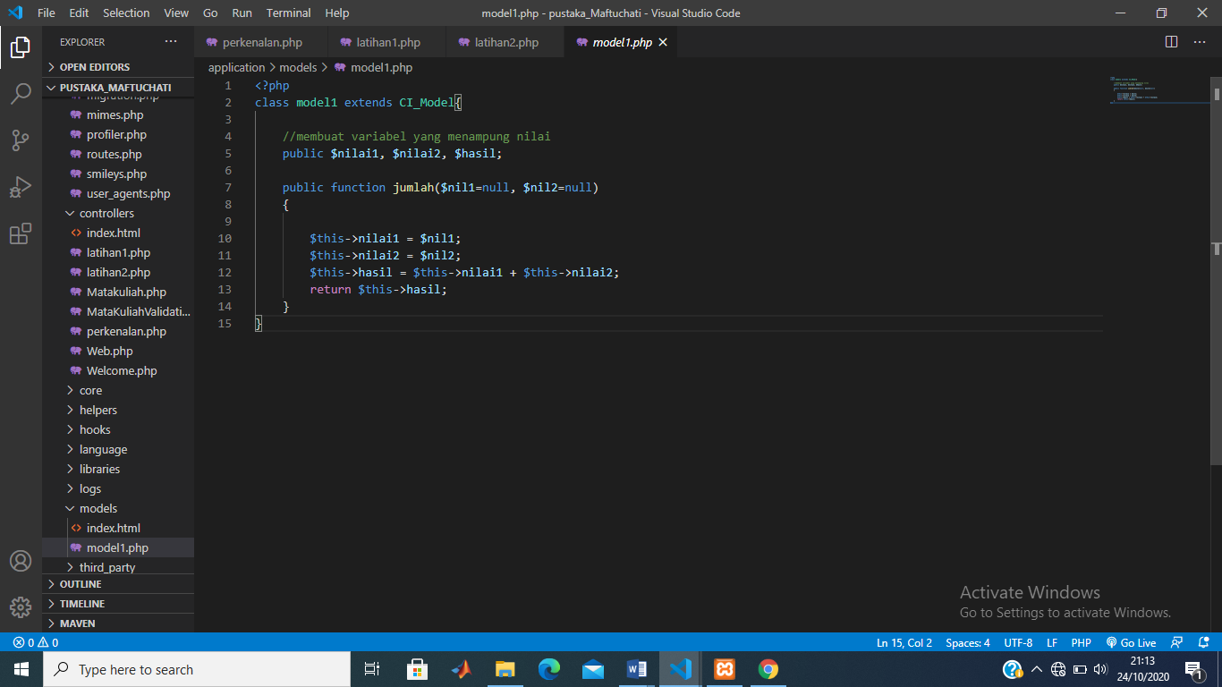

* viewlatihan1.php->application/view

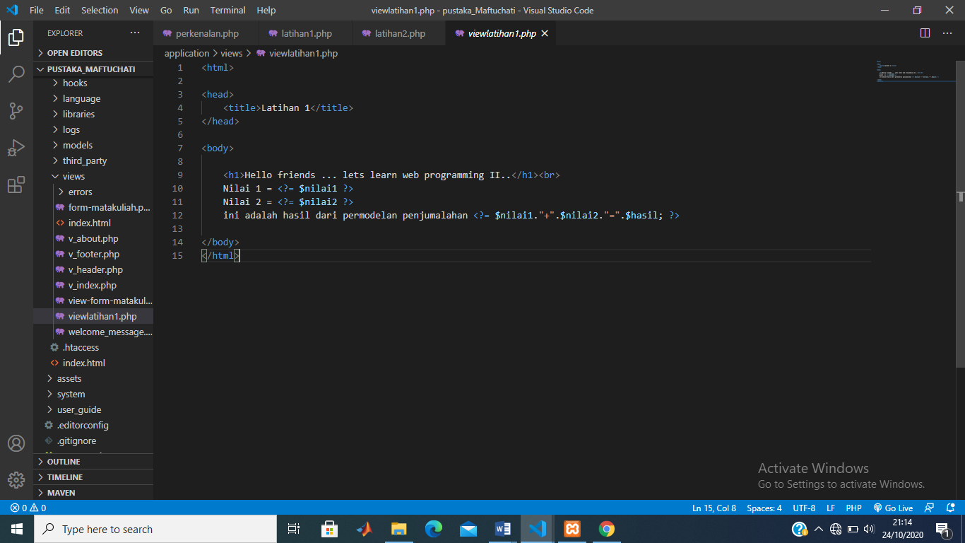

1. URL

<http://localhost/pustaka_Maftuchati/index.php/latihan1>

<http://localhost/pustaka_Maftuchati/index.php/latihan2>

<http://localhost/pustaka_Maftuchati/index.php/latihan2/penjumlahan/1/6>

<http://localhost/pustaka_Maftuchati/index.php/latihan1/penjumlahan/4/5>

1. Capture Hasil

* **Hasil run latihan 1 dan 2 hasinya sama**

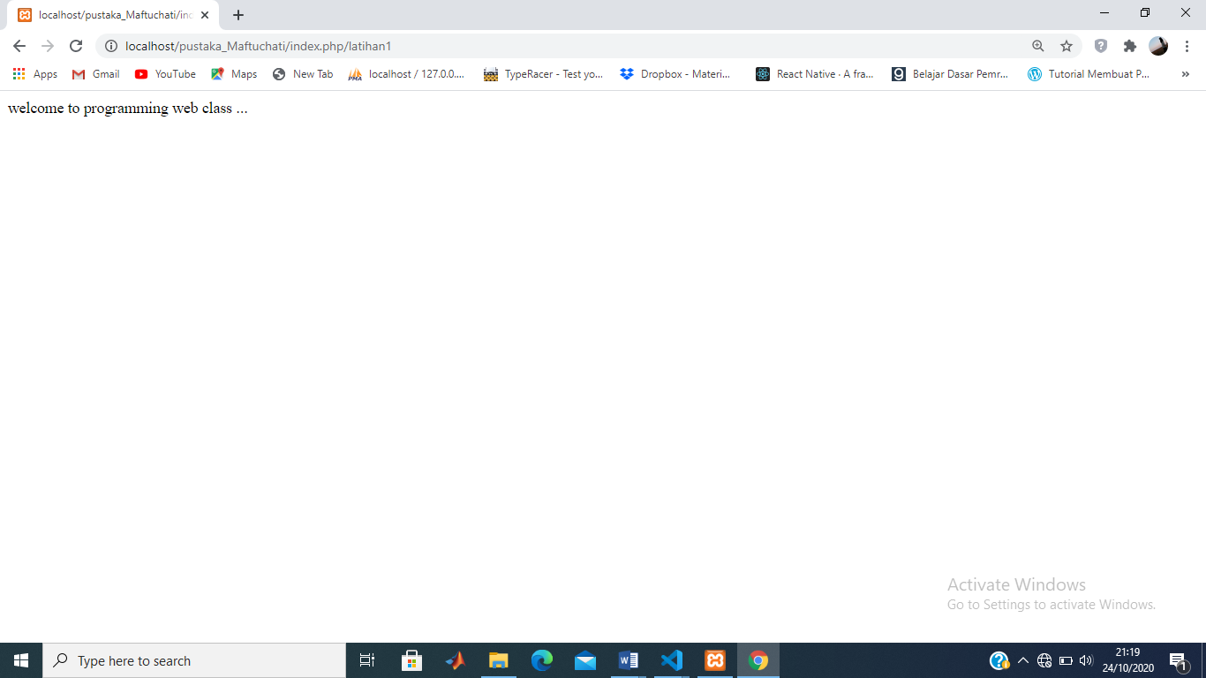

* **Hasil run viewlatihan1**

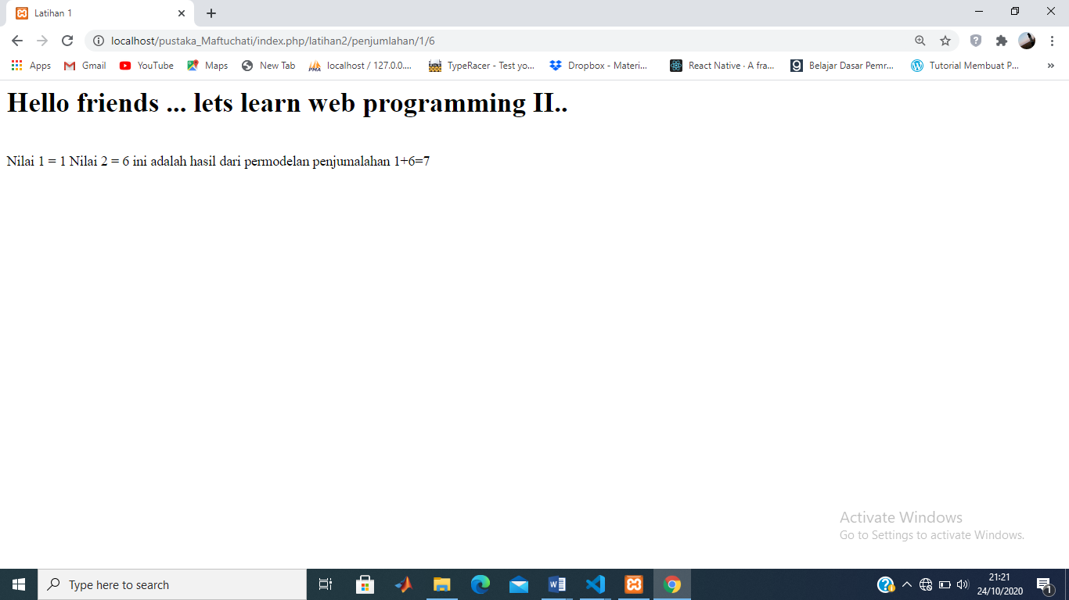

* **Hasil run penjumlahan**

